Errors and their solutions

1. While trying to open a deal slip in CBMB-VMS defect

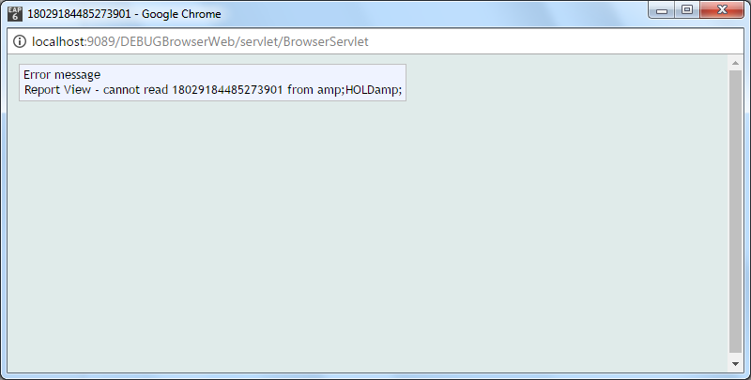

Solution: